**ASSIGNMENT QUESTIONS – V3**

1. How many rows are in the Sales query? **137**
2. How many columns are in the Sales query? **19**
3. On Sheet1 of your workbook, create a pivot table that illustrates which region has the city with the most units sold. Your pivot table must:

* Show appropriate fields
* Have a descriptive name for the value field
* Use conditional formatting to highlight the city with the highest total units sold
* Show subtotals at the top of each group

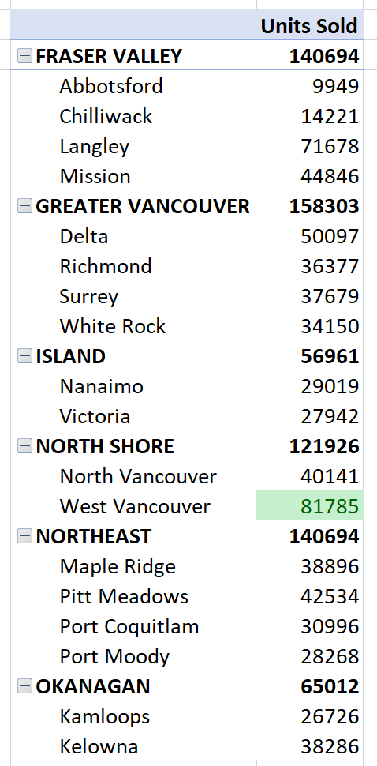

1. Referencing this pivot table, which region had the most units sold? **Greater Vancouver**
2. Continuing in Sheet1 of your workbook, create a single pivot table that shows the average number of payment days by sales channel and the average discount rate percentage for the order year 2020. Your pivot table must:

* Show appropriate fields
* Be filtered appropriately
* Show payment days as an integer
* Show discount rate as a percentage with two decimal places

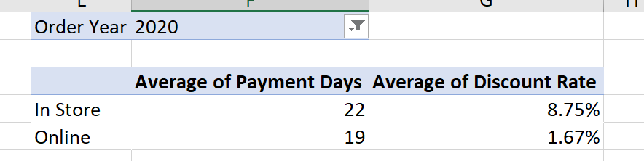

1. Referencing this pivot table, what is the average discount rate for the online channel? **1.67%**
2. Referencing this pivot table, which sales channel has the lowest average payment days? **Online**
3. Continuing in Sheet1 of your workbook, create a pivot table that shows the total profit by city and sales channel. Format your values to show as a percent of the grand total and apply data bar conditional formatting to your pivot table. Your pivot table must:

* Show city as row, sales channel as column
* Show values as a percent of grand total rounded to two decimal places
* Apply data bar conditional formatting to all cells showing sum of total profit values for city and sales channel
* Sort descending by grand total

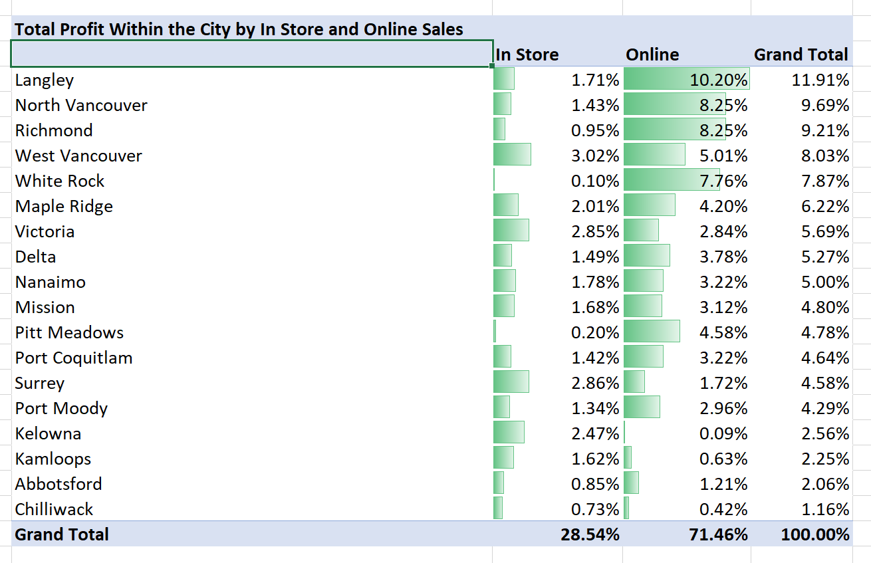

1. Which city contributes the least to total profit? **Chilliwack**
2. Which of the following statements is NOT true?

* Langley’s profits represent more than 10% of total profits.
* Langley has the highest profits in both sales channels. **FALSE**
* Most of the company’s profits are generated in Langley.
* Most of the company’s profits are generated online.

1. Continuing in Sheet1 of your workbook, create a pivot table that allows you to answer the following question > What were the total sales by region in 2021 for each item type. Your pivot table must:

* Show the correct level of granularity
* Not include any extraneous information

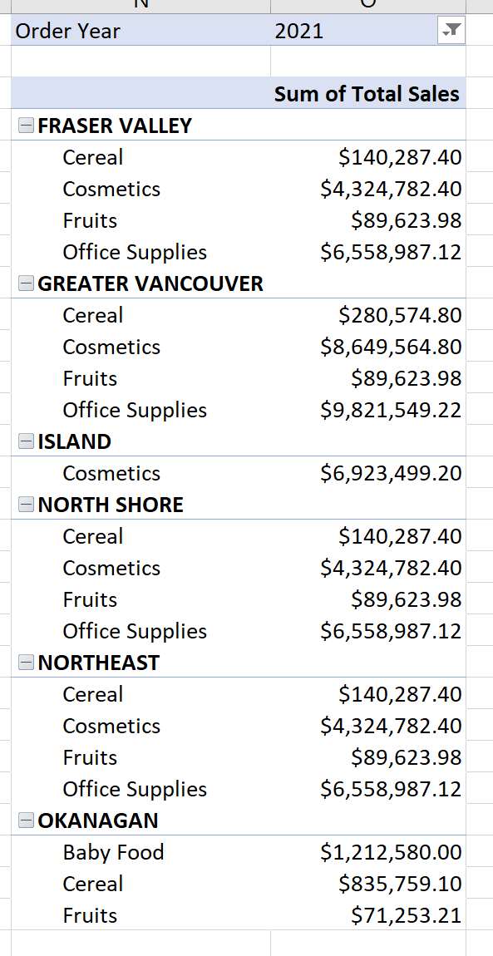

1. What is the value of fruit sales in the Okanagan in 2021? **$71,253.21**
2. Continuing in Sheet1 of your workbook, create a pivot table that allows you to answer the following question > How many Total Orders were discounted by Discount Type for each Order Year? Your pivot table must:

* Show the correct level of granularity
* Not include any extraneous information

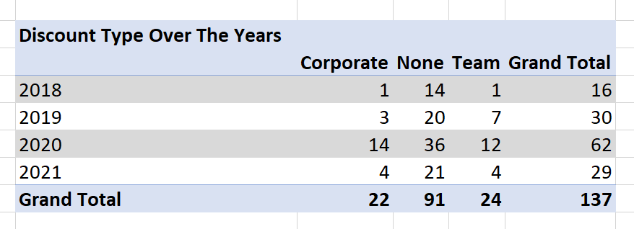

1. How many orders received a Team discount in 2020? **12**
2. Which discount type was applied to the most orders? **None**